kensington metropark

2240 West Buno Road
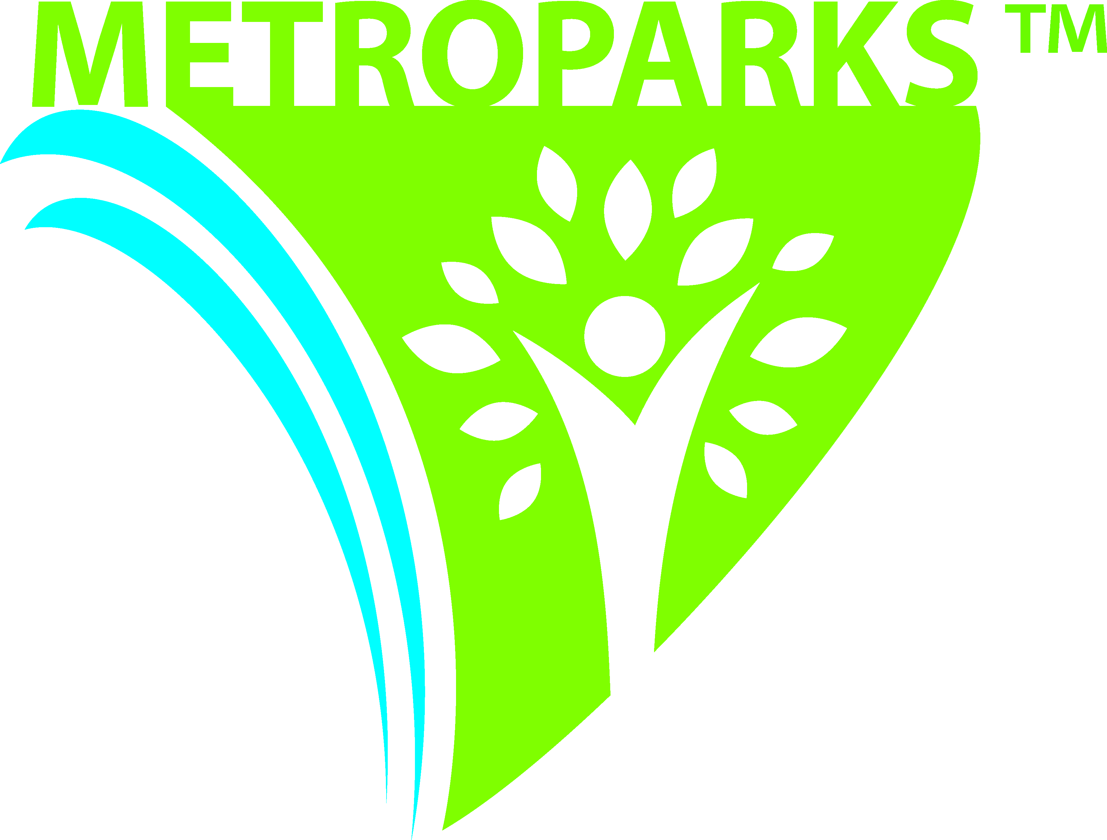
Milford, MI 48380-4410
Phone: 810-227-8910
Fax: 248-684-5836
www.metroparks.com

ISLAND QUEEN III

The Island Queen III is a 46-passenger pontoon boat that provides rides around Kent Lake. The Island Queen is available for public rides and private charters. All rides are approximately 45-50 minutes long. The Island Queen runs Mid-May through mid-October. During the months of May, September, and October the Island Queen operates on weekends only; check with the Park Office regarding specific dates and fall color tours. Reservations for morning or evening charters are made through the Park Office. Charter reservations should be made a minimum of ten days in advance.

PUBLIC RIDES: The Island Queen III leaves the dock daily from 12 noon to 6 pm on the hour. Tickets are available at the Boat Rental building and are on a first-come, first-served basis. The cost for public rides is: $6 per adult, $4 children (12 and under) and Senior Citizens (62 and over). Children 2 years and under are free of charge.

PRIVATE CHARTERS: Cost is $100 per hour. The $100 per hour fee is due in advance of your charter.
Morning charter times: 10 & 11 am
Evening charter times: 7 & 8 pm

CANCELLATIONS: Charters can be cancelled or rescheduled, if time slots are available. Cancellations due to inclement weather require a 4-hour notice. A 24-hour notice is required for any other reason. Anything less will result in the forfeiture of the payment. The Island Queen II will not operate during the threat of severe weather, including strong winds. Refunds take approximately 4-6 weeks to process. For cancellations, contact the Park Office as soon as possible.

The Island Queen can accommodate up to 6 wheelchairs. It does not have electrical access, restrooms, or tables (bench-type seating only). Pets are prohibited on the Island Queen; unless it is a service dog. Beer and wine are permitted (no glass containers) only when the Island Queen III is privately chartered. Alcohol is not permitted on public rides. Special requests, such as music, generator, caterer, etc. must receive prior approval. Please be sure to let the reservationist know you’re planning such activities. If your group plans on having food and beverages aboard and/or requires additional food service area, passenger capacity will be reduced.

Park entry fees are not included in the reservation fee. A fee of $10 per vehicle on the weekdays, weekends and holidays, or $35 per vehicle for an annual sticker ($24 for a senior annual) is required on all vehicles entering the park and may be obtained at the tollbooths or Park Office. If you would like to pay for your guest`s park entrance fee, contact the Park Office a minimum of 1 week prior to the event.

