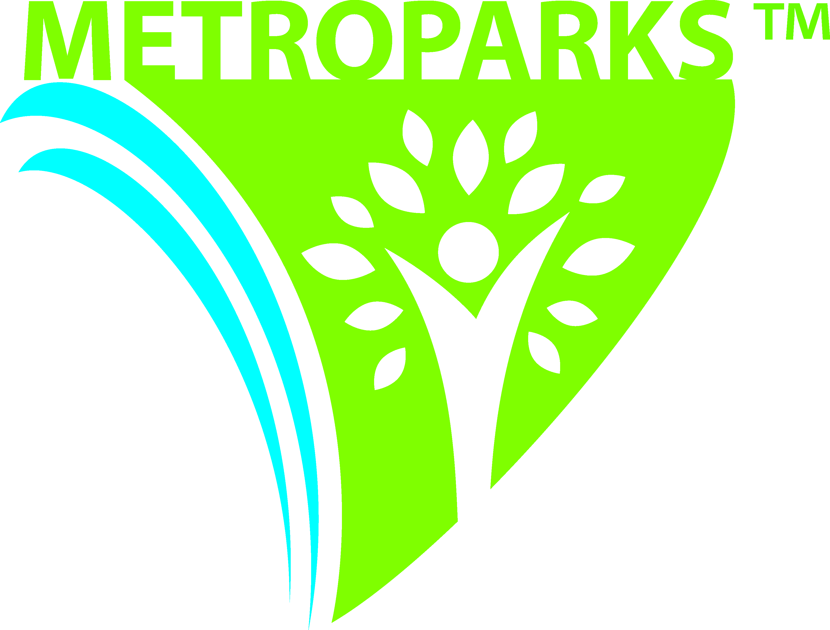
KENSINGTON METROPARK
2240 WEST BUNO RD.
MILFORD, MI 48380-4410
PHONE: (810) 227-8910 ● FAX: (248) 684-5836
www.metroparks.com

PICNIC INFORMATION FOR 2019

FOR THE BEST PICNIC EXPERIENCE POSSIBLE, WE RECOMMEND THAT YOU COME OUT AND VIEW THE SITES BEFORE YOU RESERVE OR REGISTER YOUR PICNIC.

- RESERVED SHELTERS:
Kensington Metropark has fifteen shelters, which can be reserved for summer picnics, reunions, and other gatherings. These shelters accommodate 40-130 people and are available for a fee of $225 for one day’s use. The reservation fee of $225 is due at the time of your reservation. Additionally, you are reserving the shelter only and not the surrounding area. If your group requires more site area and/or picnic tables than what the shelter accommodates, you are responsible for securing the tables as soon as the site is open at 6 am. The public may utilize any unused picnic tables in your area on a first-come, first-served basis. To reserve a shelter, contact the Park Office to check availability. The application must be completed and returned within two weeks of receiving it (payment is due upon reservation). We accept all credit cards. Checks or money orders should be made payable to H.C.M.A. (Huron-Clinton Metropolitan Authority).
- REGISTERING:
If you do not reserve a shelter, registering your picnic is another option. This does not guarantee a site, but by registering your group, those attending your picnic can be assisted by park staff in finding your picnic location. PICNIC AREAS WITHIN THE PARK ARE AVAILABLE ON A FIRST-COME, FIRST-SERVE BASIS. Groups of any size are required to register with the park office at least two weeks in advance. It is recommended that someone from your group arrive at or after 6 am to secure a site. If your group is planning an event of 50 or more people, or if your group is planning to bring in any special equipment or special activities (dunk tanks, moonwalks, generator, canopy, caterer, etc.) an application must be completed and approved by our office in advance. A certificate of insurance may also be required.
- CANCELLATIONS AND RAIN DATES:
A cancellation of a reservation will result in the forfeiture of the entire reservation fee unless we are given a two week notice in which to re-rent the shelter. If a refund is issued there is a $25 processing fee. If it is determined that weather conditions will not permit the use of the shelter, your reservation may be postponed to any future date not already reserved within the calendar year. To reschedule your picnic due to weather, you MUST contact the Park Office before noon on the day of your picnic.
- PARK ENTRY FEE:
A fee of $10 per vehicle seven days a week, or $35 per vehicle for a Metropark annual permit ($24 for a senior annual) is required on all vehicles entering the park and may be obtained at tollbooths or the park office. Anyone bringing in a boat (on a trailer) is subject to an additional launching fee. Park entry fees are not included in the reservation fee. This also includes event companies and canopy rental personnel. Group billing is available. Please contact the Park Office for more information.
- HOURS:
The park hours are 6 am to 10 pm every day.
- CLEAN-UP AND DAMAGES:
The reserving individual will be held financially responsible for damage beyond normal wear and tear and will be billed for damage and/or clean up. It is your responsibility to leave the park area as clean as you found it.
- OFF-ROAD PERMITS:
We will issue off-road permits to the driver of the vehicle on the day of the event for APPROVED REASONS ONLY: canopy (no sides), caterer, inflatables, large grills, and disabled persons. Those with small coolers and limited picnic supplies will NOT be issued off-road permits, please be prepared to carry your items to picnic areas. Obtain permits at the Park Office on the day of the event. There is no charge for the permits. This permit is for loading and unloading supplies only. THE NUMBER OF OFF-ROAD PERMITS WILL BE LIMITED FOR EACH GROUP. Obtain off-road permits at the Park Office (driver’s name, description of vehicle and license plate number are required).
- CATERING:
Kosch Catering is the preferred catering company for Kensington Metropark’s picnic areas. If you choose not to have your event catered, you are welcome to bring in your own food. For additional information or to schedule food or beverage services please contact Kosch Catering at 248-608-0690 or at www.koschcatering.com.
- ELECTRICITY AND WATER:
There is NO POWER in any of the picnic shelters or picnic areas. Generators are permitted, please indicate on your application. All generators must be a quiet/silent running unit. Hand pump water is available throughout the park areas. You may not hook up a hose to any of our restroom facilities or faucets.
- PETS:
Dogs must be on a maximum 6’ leash and in your attendance at all times. Dogs are not permitted in/at the swimming and sandy portions of Martindale Beach, Horse Trails, Nature Center, Nature Trails and Farm Center.
- ALCOHOL:
Beer and wine are permitted in the picnic areas only; NO HARD LIQUOR. No alcohol of any kind is permitted at the beach, Farm Center, and Nature Center or any indoor facility. No glass bottles at the beaches.
- EQUIPMENT AND ATHLETICS:
Canopies only; dome tents are not permitted. If you choose to bring in a dunk tank, you must bring in your own water for the tank. Dunk tanks, inflatables, organized athletic competitions, and activities other than common picnic activities require prior approval and they must be listed on your application. Some of these activities will require Comprehensive General Liability Insurance – Bodily Injury and Property Damage, naming the Huron-Clinton Metropolitan Authority as additional insured or the certificate holder, an Endorsement, as well as a Special Agreement for use of Inflatable, Mechanical Rides and Dunk Tanks on Metropark property; which must be completed by the supplier of the equipment. For further information, contact the Park Office.
- SIGNS:
If you wish to put up signs to direct your group to the location of your picnic, you may do so on the day of your event. We recommend bright colored and dark lettered signs placed at park intersections. The signs may be no larger than 12” x 12” and freestanding (placed on posts that you provide). Do not place signs on park gates, trees, signs, or picnic shelters because park personnel will be forced to remove them. Please remove your signs at the end of the day.
- SWIMMING:
Martindale Beach will be open for swimming on a daily basis from Memorial weekend thru Labor Day from 10 am to 8 pm.

