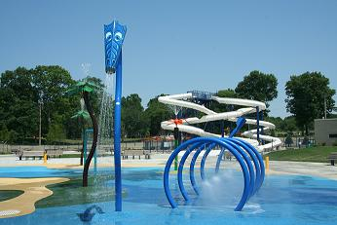
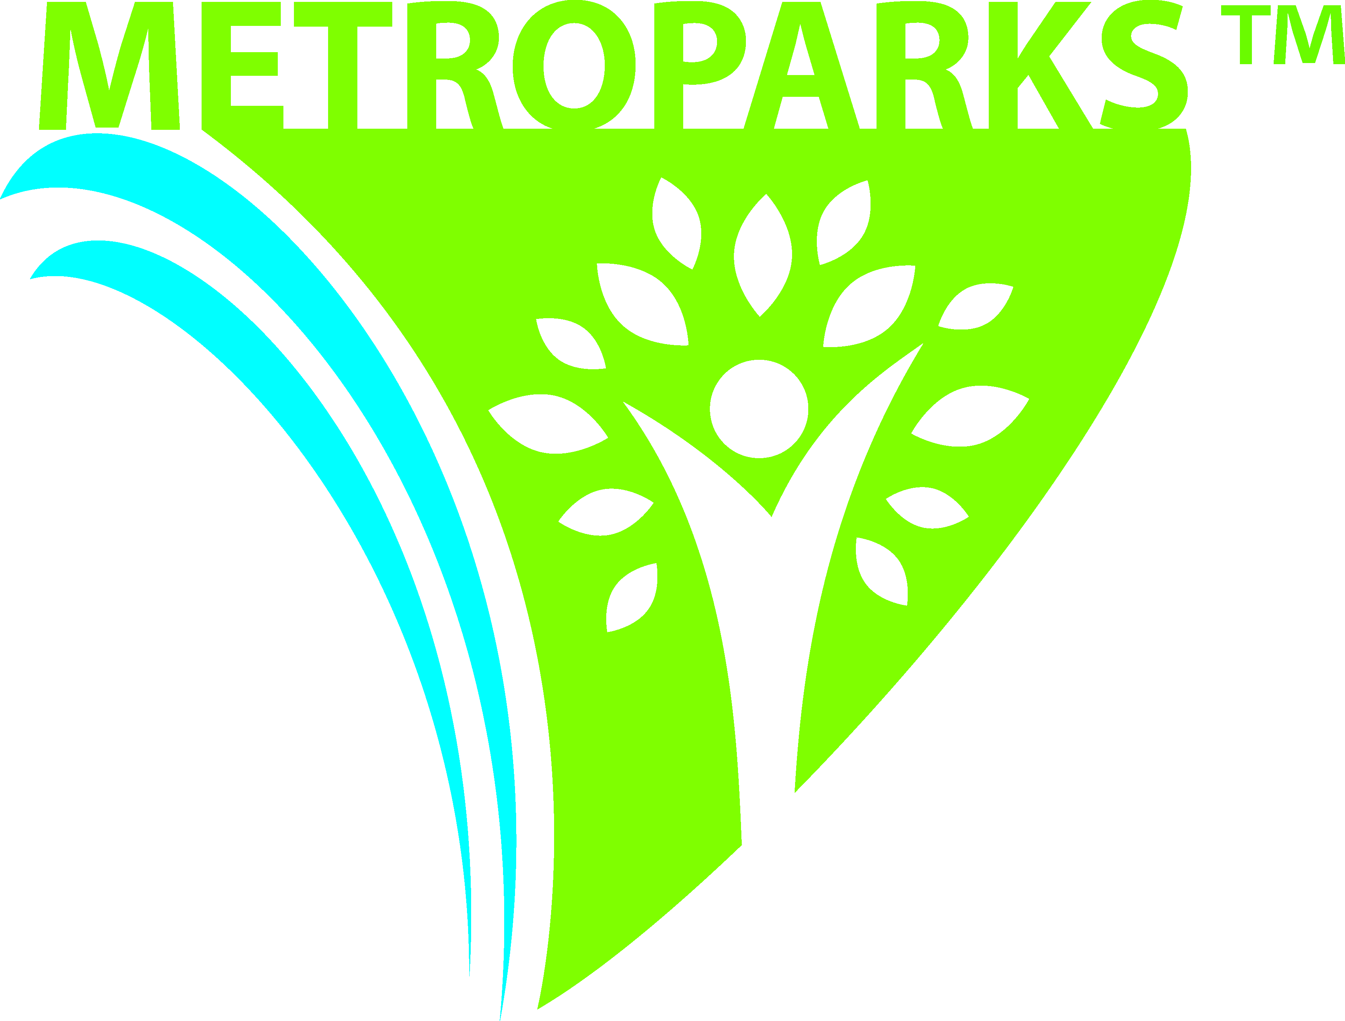
kensington metropark

2240 West Buno Road, Milford, MI 48380-4410
Phone: 810-227-8910 ● Fax: 248-684-5836
www.metroparks.com

SPLASH ‘n’ BLAST WATER PLAY AREA

The Splash ‘n’ Blast contains two 240-foot twisted waterslides and an adjacent spray area. Slide down the open slide or ride down in the dark through the enclosed slide. Have a blast in the spray area as water shoots from cannons, palm trees, serpents and a whale. The Splash ‘n’ Blast is located on the north end of Martindale Beach in Kensington Metropark.

PUBLIC HOURS OF OPERATION • The Splash ‘n’ Blast is open 11 am to 7 pm, weather permitting; open Memorial Weekend thru Labor Day. No group reservations during regular operating hours.

FEES • $7 Adults and children 42” or taller, $6 for seniors, adults and children under 42” and children and adults under 30” are free. After 5 pm the special twilight rate of $6 for adults and children 42” or taller, $5 for adults and children under 42”, $5 for seniors is also in effect and children/adults under 30” are free. We accept all credit cards and checks with proper identification at the Splash ‘n’ Blast. A wristband will be issued upon payment which allows you entry throughout the day/public hours of operation (exceptions would be: Splash ‘n’ Blast has reached its capacity, facility is closed due to mechanical problems, and/or inclement weather). Park entry fees are not included in the admission or private rental fees. A fee of $10 per vehicle on the weekdays, weekends and holidays, or $35 per vehicle for an annual sticker ($24 for a senior annual) is required on all vehicles entering the park and may be obtained at the tollbooths or Park Office. Group billing is also available. Please contact the Park Office for more information.

AFTER HOURS GROUP RATES • Private rental of the Splash ‘n’ Blast is available from 10 am to 11 am and from 7 pm to 8 pm. The cost is $200 per hour for groups of 75 people or less, payment is due at the time of reservation. An additional fee of $4 per person is charged for 76 people or more; maximum capacity of 500 people. Reservations for private rentals are made through the Park Office. A minimum of 10 days notice is required for rental of the Splash ‘n’ Blast. Credit card payments are accepted for group rental at the Park Office. All groups wishing to have food catered may contact Kosch Catering at 248-608-0690, www.koschcatering.com. The Splash ‘n’ Blast will not be available for private rental on Memorial Day, July 4th, and Labor Day.

CANCELLATIONS • Reservations can be cancelled or rescheduled, if time slots are available. Cancellations due to inclement weather require a 4-hour notice. A 24-hour notice is required for any other reason. Anything less will result in the forfeiture of the payment. The Splash ‘n’ Blast will not operate during inclement weather. If the park staff is forced to cancel your reservation, due to weather or equipment issues, a full refund will be issued or the group will have an opportunity to reschedule. Refunds take approximately 4-6 weeks to process. For cancellations, contact the Park Office as soon as possible.

GENERAL RULES • Please refer to posted signs in the Splash-n-Blast area for additional rules.
- All waterslide riders must be at least 42” tall.
- No jewelry, piercings or watches on the waterslides. No cut-off jeans or swimwear with exposed zippers, buckles, rivets or metal ornamentation; only approved swimsuits are allowed.
- An adult must pay entry and accompany a child that is under 10 yrs of age into the Splash-n-Blast even if they are not using the waterslides or spray area.
- Adults can not ride the slide with a child. Only one person is permitted to go down the slide at a time.
- Food and beverages will be allowed in the picnic table area of the Splash ‘n’ Blast only. No glass containers.
- Tobacco, drug and alcohol-free facility.

Reservations can be made by calling the Park Office at 810-227-8910.

